Basic Lambda: Define a lambda expression that takes two integers as arguments and returns their sum. Use auto to infer the return type.

#include <iostream>

int main() {

auto add = [](int x, int y) {

return x + y;

};

int result = add(24, 65);

std::cout << "The sum is: "<<result<<std::endl;

return 0;

}

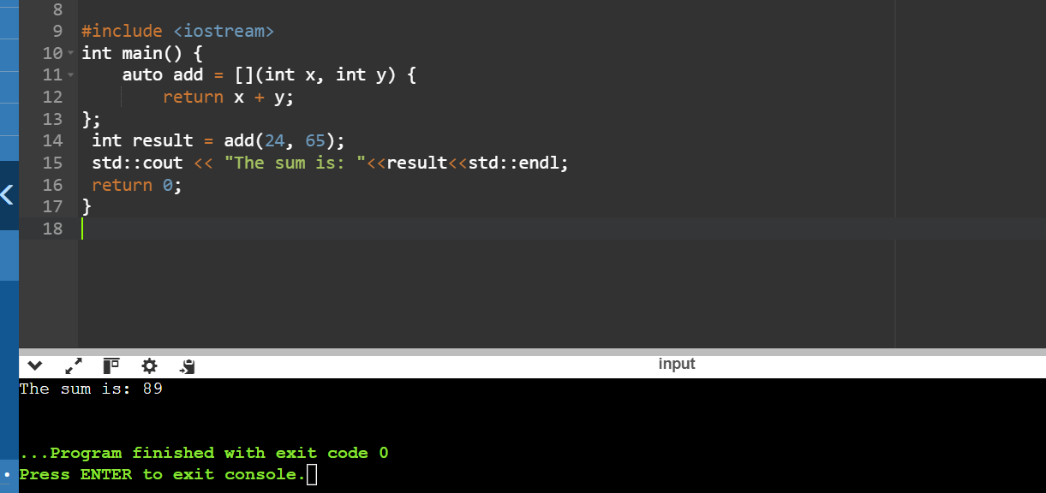

Capture by Value: Write a lambda that captures an integer by value from the enclosing scope, squares it, and returns the result.

#include <iostream>

using namespace std;

int main() {

int a = 23;

auto square = [a]() { return a * a; };

int result = square();

cout << "The square of " << a << " is: " << result << endl;

return 0;

}

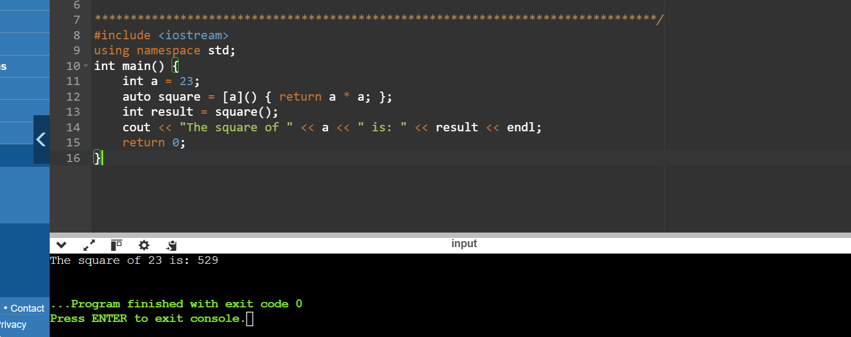

Capture by Reference: Create a lambda that captures a string by reference, appends a fixed prefix, and returns the modified string.

#include <iostream>

#include <string>

int main() {

std::string str = "everyone";

auto appendPrefix = [&str]() {

str = "\nhey, " + str;

return str;

};

std::cout << "Modified string: "<<appendPrefix()<<std::endl;

return 0;

}

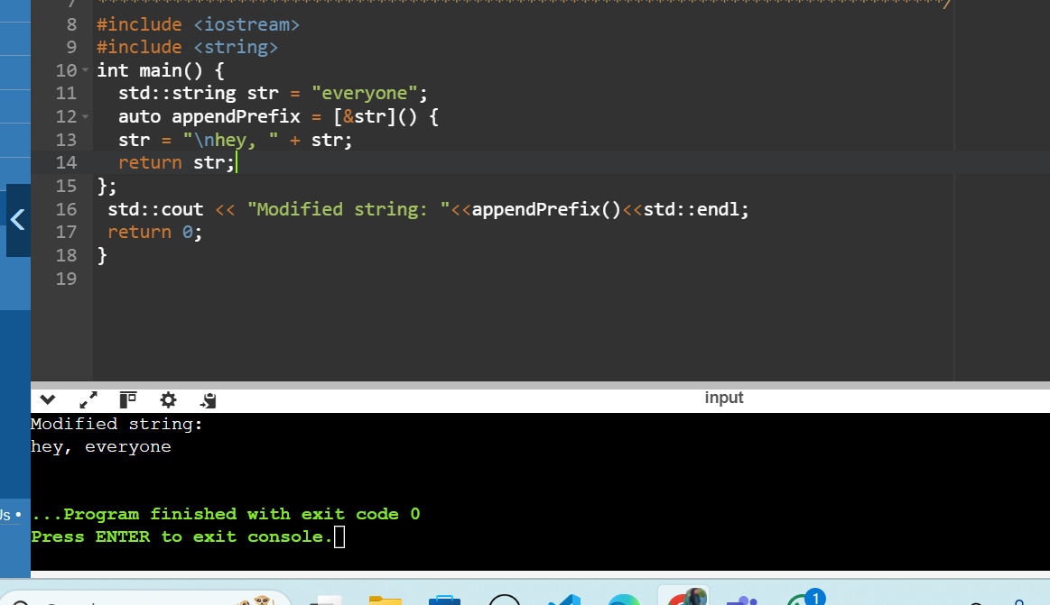

Multiple Captures: Construct a lambda that captures two variables (an integer and a boolean) by value and performs a conditional operation based on the boolean value.

#include <iostream>

using namespace std;

int main() {

int num = 49;

bool cond = true;

auto lambda = [num, cond]() mutable {

if (cond) {

num *= 2;

} else {

num /= 2;

}

return num;

};

cout << "Result: " << lambda() << endl;

return 0;

}

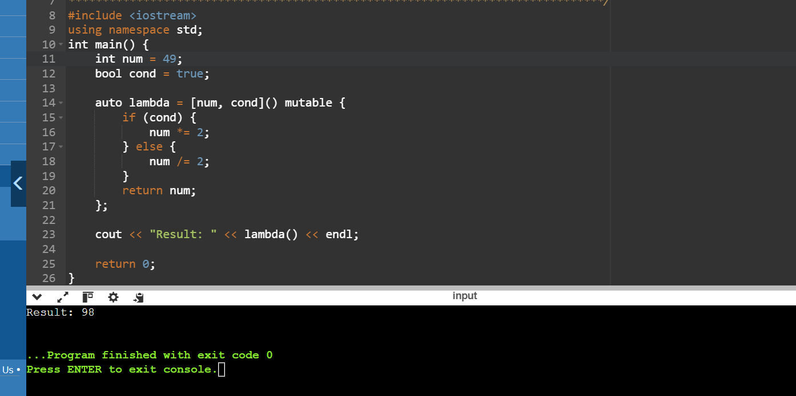

1. const_cast (expr)

Purpose: Casts away the const or volatile qualifier from an expression. This allows modifying a supposedly constant variable, but be cautious as it can break code that relies on const-correctness.

Use Cases: This is generally discouraged as it can lead to unexpected behavior. However, it might be necessary in rare cases when working with legacy code or APIs that don't handle const correctly.

#include <iostream>

void modifyConstant(const int* ptr) {

int* modifiable_ptr = const_cast<int*>(ptr);

*modifiable_ptr = 66;

}

int main() {

int a = 50;

std::cout << "Before modify Constant: "<<a<<std::endl;

modifyConstant(&a);

std::cout << "After modify Constant: "<<a<< std::endl;

const int b = 70;

std::cout << "Before modifying const variable y: "<<b<<std::endl;

modifyConstant(&b);

std::cout << "After modifying const variable y: "<<b<<std::endl;

return 0;

}

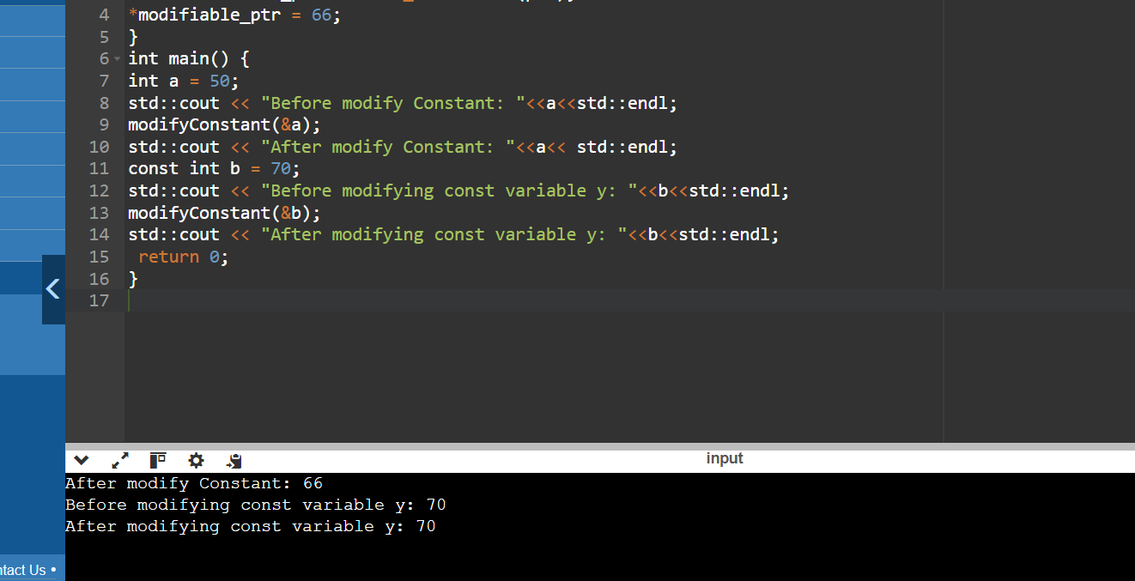

2. dynamic_cast (expr)

Purpose: Performs a runtime check to see if a pointer or reference to a base class can be safely cast to a derived class type. If the cast fails (i.e., the object isn't actually of the derived type), it returns nullptr.

Use Cases: This is particularly useful for working with polymorphism in inheritance hierarchies. It ensures type safety and avoids potential errors from incorrect casting.

#include <iostream>

class Base {

public:

virtual void display() {

std::cout << "Base class" << std::endl;

}

virtual ~Base() {}

};

class Derived1 : public Base {

public:

void display() override {

std::cout << "Derived class 1" << std::endl;

}

};

class Derived2 : public Base {

public:

void display() override {

std::cout << "Derived class 2" << std::endl;

}

};

int main() {

Base* base_ptr = new Derived1();

Derived1* derived1_ptr = dynamic_cast<Derived1*>(base_ptr);

if (derived1_ptr) {

std::cout << "Dynamic cast to Derived1 successful:" << std::endl;

derived1_ptr->display();

}

else

{

std::cout << "Dynamic cast to Derived1 failed!" << std::endl;

}

Derived2* derived2_ptr = dynamic_cast<Derived2*>(base_ptr);

if (derived2_ptr) {

std::cout << "Dynamic cast to Derived2 successful:" << std::endl;

derived2_ptr->display();

}

else

{

std::cout << "Dynamic cast to Derived2 failed!" << std::endl;

}

delete base_ptr;

return 0;

}

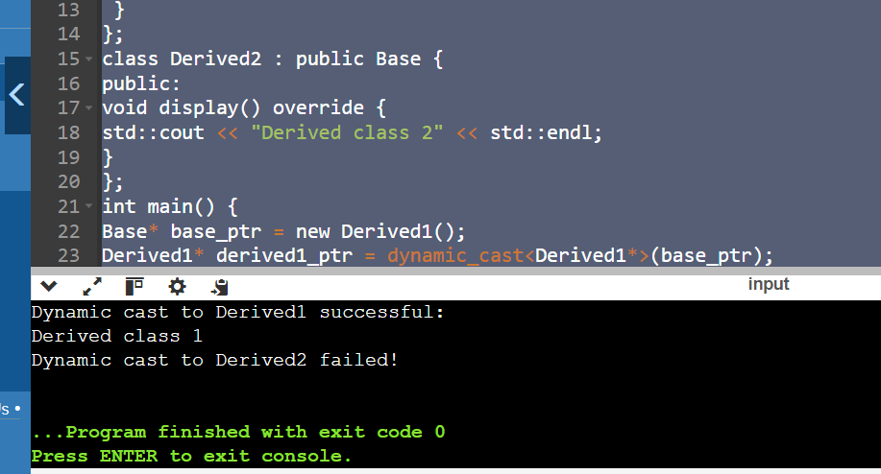

3. reinterpret_cast (expr)

Purpose: Reinterprets the bit pattern of an expression as a different type. This allows casting pointers to different pointer types, converting pointers to integers and vice versa (low-level operations). However, it's very powerful and can lead to undefined behavior if not used carefully.

Use Cases: This is for advanced scenarios like memory manipulation or interfacing with low-level hardware. Use it with extreme caution as it bypasses type checking.

#include <iostream>

class Base {

public:

virtual void display() {

std::cout << "Base class" << std::endl;

}

virtual ~Base() {} // Virtual destructor for polymorphic behavior

};

class Derived1 : public Base {

public:

void display() override {

std::cout << "Derived class 1" << std::endl;

}

};

class Derived2 : public Base {

public:

void display() override {

std::cout << "Derived class 2" << std::endl;

}

};

int main() {

Base* base_ptr = new Derived1();

// Using reinterpret_cast to reinterpret base_ptr as Derived1*

Derived1* derived1_ptr = reinterpret_cast<Derived1*>(base_ptr);

if (derived1_ptr) {

std::cout << "Successfully reinterpreted to Derived1:" << std::endl;

derived1_ptr->display();

} else {

std::cout << "Failed to reinterpret as Derived1!" << std::endl;

}

// Using reinterpret_cast to reinterpret base_ptr as Derived2*

Derived2* derived2_ptr = reinterpret_cast<Derived2*>(base_ptr);

if (derived2_ptr) {

std::cout << "Successfully reinterpreted to Derived2:" << std::endl;

derived2_ptr->display();

} else {

std::cout << "Failed to reinterpret as Derived2!" << std::endl;

}

delete base_ptr;

return 0;

}

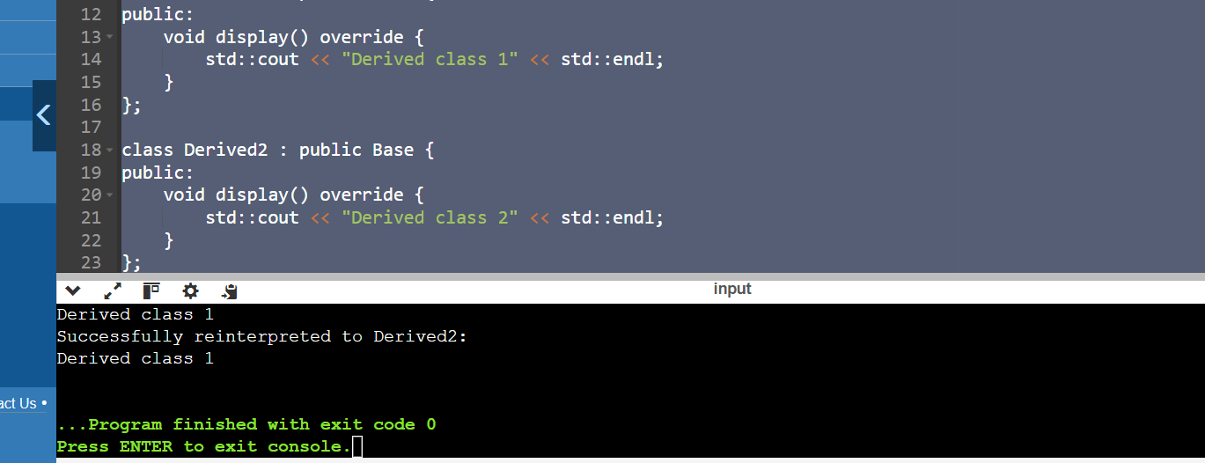

4. static_cast (expr)

Purpose: Performs a basic type conversion between compatible types. It's similar to implicit conversions but allows explicit control.

Use Cases: This is commonly used for converting between related data types like int to float or casting a base class pointer to a derived class pointer (upcasting). It's generally safe as long as the conversion is valid.

#include <iostream>

class Base {

public:

virtual void display() {

std::cout << "Base class" << std::endl;

}

virtual ~Base() {} // Virtual destructor for polymorphic behavior

};

class Derived1 : public Base {

public:

void display() override {

std::cout << "Derived class 1" << std::endl;

}

};

class Derived2 : public Base {

public:

void display() override {

std::cout << "Derived class 2" << std::endl;

}

};

int main() {

Base* base_ptr = new Derived1();

// Using static_cast to cast base_ptr as Derived1*

Derived1* derived1_ptr = static_cast<Derived1*>(base_ptr);

if (derived1_ptr) {

std::cout << "Static cast to Derived1 successful:" << std::endl;

derived1_ptr->display();

}

else {

std::cout << "Static cast to Derived1 failed!" << std::endl;

}

Derived2* derived2_ptr = static_cast<Derived2*>(base_ptr);

if (derived2_ptr) {

std::cout << "Static cast to Derived2 successful:" << std::endl;

derived2_ptr->display();

}

else {

std::cout << "Static cast to Derived2 failed!" << std::endl;

}

delete base_ptr;

return 0;

}



Code: #include <iostream>

#include <typeinfo> // for dynamic_cast

class Base {

public:

virtual void whoami() {

std::cout << "I am a Base class object" << std::endl;

}

virtual ~Base() {} // Adding virtual destructor for polymorphic behavior

};

class Derived : public Base {

public:

void whoami() override {

std::cout << "I am a Derived class object" << std::endl;

}

};

int main() {

// static_cast example (truncating double to int)

double num = 3.14159;

int integer_part = static_cast<int>(num); // Truncates the decimal

std::cout << "Original number: " << num << std::endl;

std::cout << "Integer part: " << integer_part << std::endl;

// Incorrect upcasting (assuming Derived object but not guaranteed)

// This could lead to undefined behavior if base_ptr doesn't point to a Derived

Base* base_ptr = new Derived(); // Pointer to a Base class (actually pointing to a Derived)

Derived* derived_ptr = static_cast<Derived*>(base_ptr); // Attempting to cast to Derived*

// Safer approach: check the actual type before downcasting

if (dynamic_cast<Derived*>(base_ptr) != nullptr) {

derived_ptr = static_cast<Derived*>(base_ptr); // Downcast only if safe

derived_ptr->whoami(); // Call Derived class's whoami

} else {

std::cout << "Warning: Base object might not be of type Derived" << std::endl;

}

delete base_ptr; // Release memory

// Using reinterpret_cast example

int value = 10;

float* float_ptr = reinterpret_cast<float*>(&value);

return 0;

}

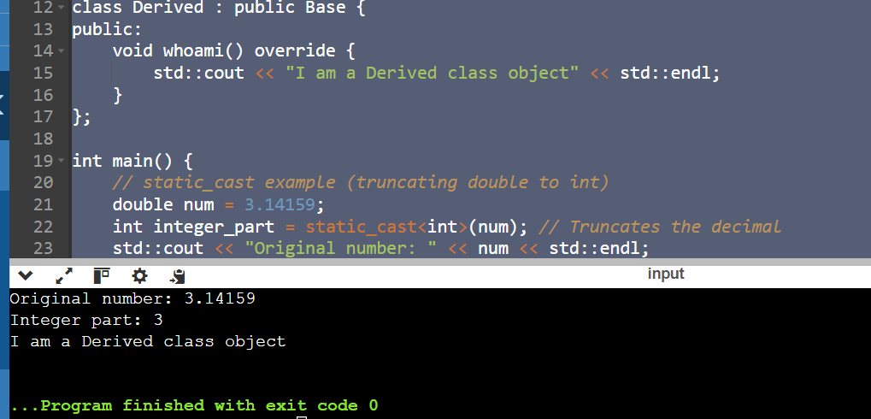

Q 1. Implicit Casting: Write a program that declares an int variable a with the value 10 and a float variable b with the value 3.14. Then, perform the division a / b and print the result. Explain how implicit casting works in this scenario.

#include <iostream>

using namespace std;

int main() {

int a = 10;

float b = 3.14;

float result = a / b;

cout << "Result of a / b: " << result << endl;

return 0;

}

Output:

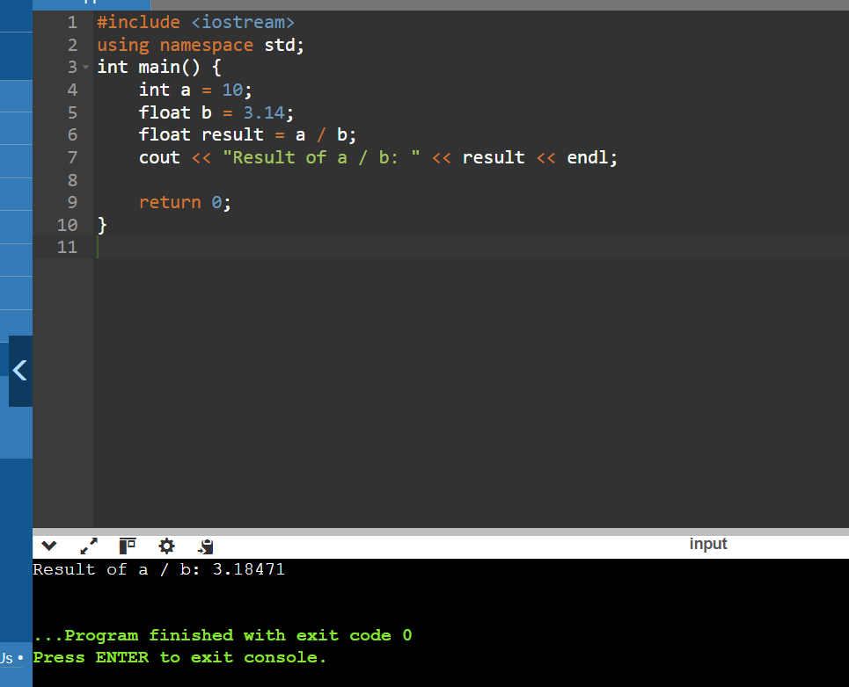

Explanation:

1) a is of type int and b is of type float.

2) Before performing the division operation, the compiler implicitly casts a from int to float.

3) The division is then performed between two float values , resulting in a float.

4) The result of the division is of type float, which is then assigned to the float variable result.

In this code the int variable a is implicitly cast to a float to match the type of b before performing the division, resulting in a float value fo

Q 2. Explicit Casting - Data Loss: Declare an int variable x with the value 256 and a char variable y. Assign the value of x to y using explicit casting. Print the value of y. Discuss the data loss that might occur and how to avoid it if necessary.

#include <iostream>

using namespace std;

int main() {

int x = 256;

char y;

y = static_cast<char>(x);

cout << "Value of y: " << static_cast<int>(y) << endl;

return 0;

}

Output:

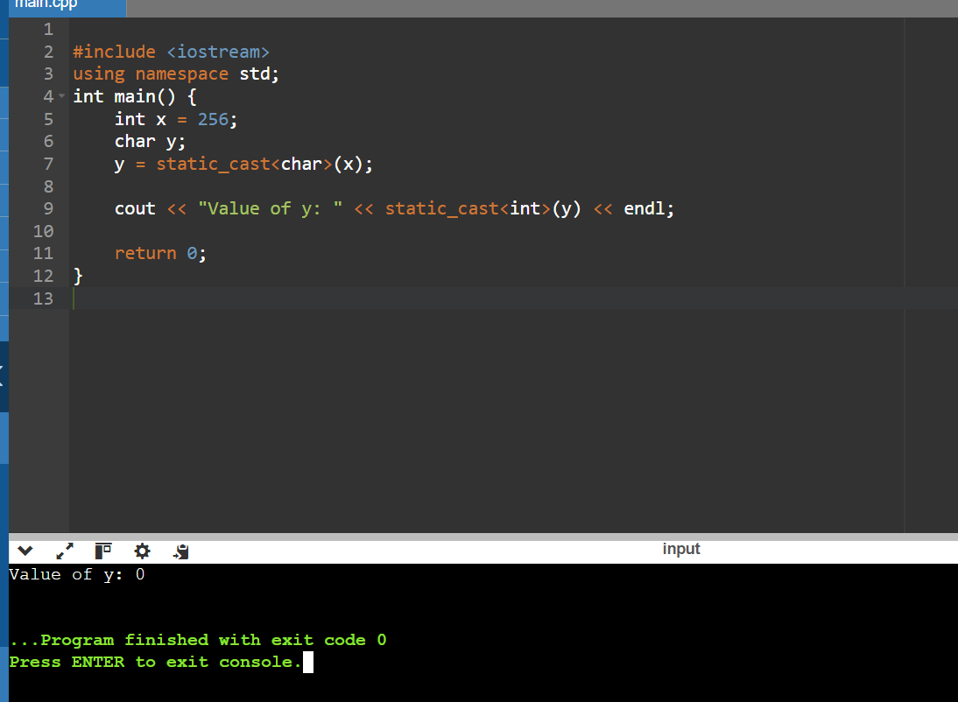

Data Loss – Yes we lost the original value of 256.The reason for this data loss is that the char type has a limited range of values (-128 to 127).when we cast the int value 256 to a char the value is fit within the char range for this reason it resulting in a value of 0.

How to avoid this – You need to store the value 256 in a char variable then consider using an unsigned char which has a range of 0 to 255.

Q 3 .Explicit Casting - Range Conversion: Declare a double variable d with the value 123.456. Use explicit casting to convert d to an int variable i and print i. Explain the behavior when converting from a larger range to a smaller one.

#include <iostream>

using namespace std;

int main() {

double d = 123.456;

int i = static_cast<int>(d);

cout << "Original double value: " << d << endl;

cout << "Converted int value: " << i << endl;

return 0;

}

Output:

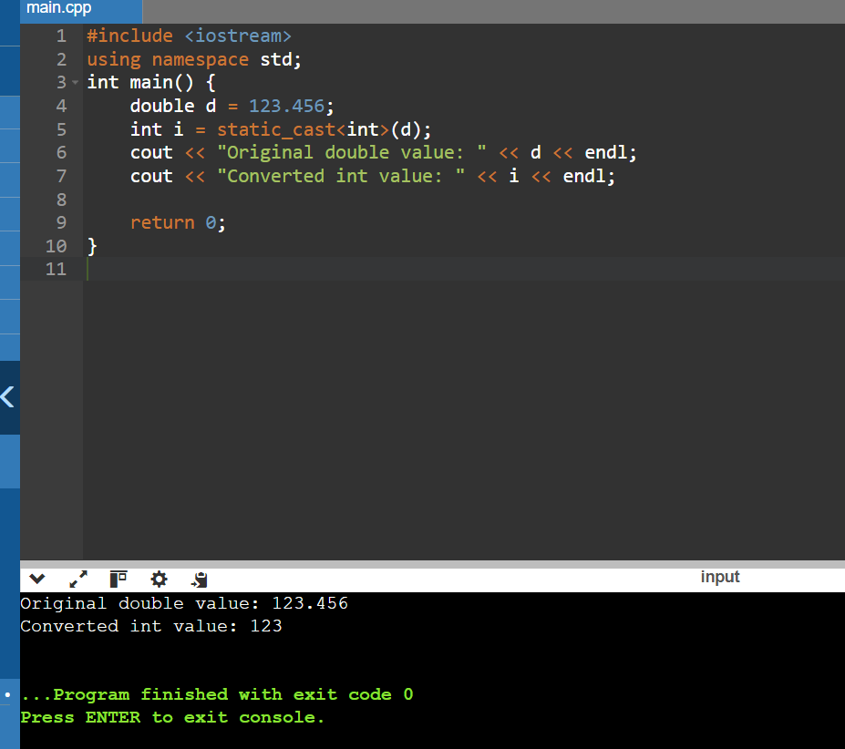

Q 4. Behavior When Converting from a Larger Range to a Smaller One - When you convert a value from a larger range (like double) to a smaller range (like int), several things can happen like Explicit casting allows you to convert a value from one type to another, with full control over the conversion process. When converting from a double to an int, the fractional part is truncated, resulting in a loss of precision. This behavior is useful when you need only the integer part of a floating-point number, but it's essential to be aware of potential precision loss and overflow issues when working with large values.

Casting Pointers - Same Type: Declare an int variable num and an int pointer ptr initialized with the address of num. Cast ptr to a float pointer fPtr using explicit casting. Is this casting safe? Why or why not?

#include <iostream>

using namespace std;

int main() {

int num = 42;

int* ptr = &num;

float* fPtr = reinterpret_cast<float*>(ptr);

cout << "Address of num: " << &num << endl;

cout << "Address stored in ptr: " << ptr << endl;

cout << "Address stored in fPtr: " << fPtr << endl;

cout << "Value at ptr: " << *ptr << endl;

cout << "Value at fPtr (interpreted as float): " << *fPtr << endl;

return 0;

}

Output:

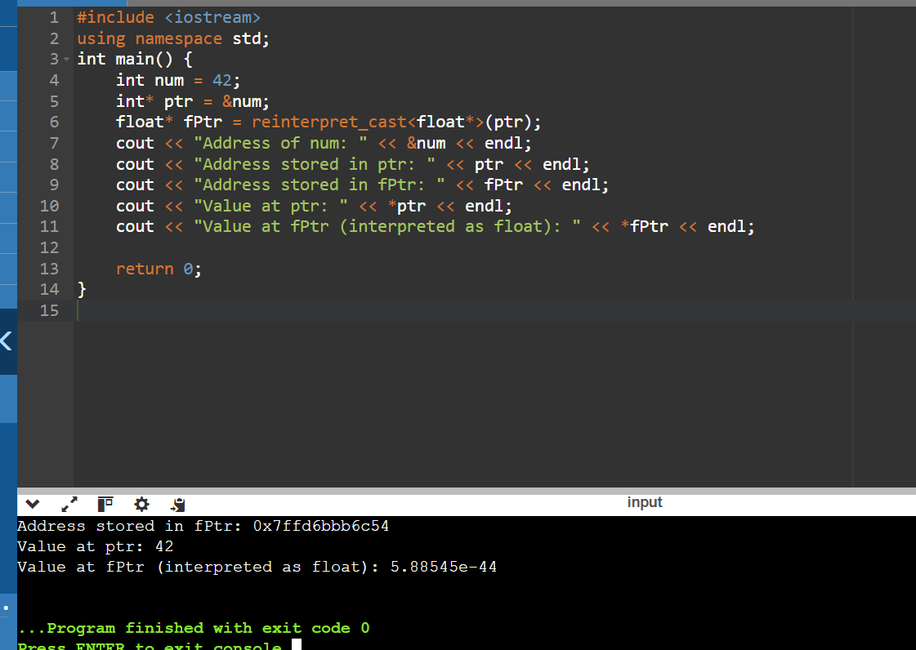

Is the casting safe or not – No the casting is not safe because

1) int and float have different internal representations. An int is typically stored as a binary integer, whereas a float is stored in IEEE 754 format, which includes a sign bit, exponent bits, and mantissa bits. Interpreting the bit pattern of an int as a float can lead to unexpected and meaningless values.

2) Different types may have different alignment requirements. Casting between incompatible pointer types can violate these requirements, potentially causing hardware traps or performance penalties on some architectures.

Q 5.Casting Pointers - Different Types: Declare an int variable num and a float variable fval. Initialize an int pointer intPtr with the address of num and a float pointer floatPtr with the address of fval. Can you safely cast intPtr to floatPtr? Explain.

#include <iostream>

using namespace std;

int main() {

int num = 45;

float fval = 2.34;

int* intPtr = &num;

float* floatPtr = &fval;

float* castedPtr = reinterpret_cast<float*>(intPtr);

cout << "Address of num: " << &num << endl;

cout << "Address stored in intPtr: " << intPtr << endl;

cout << "Address stored in castedPtr: " << castedPtr << endl;

cout << "Value at intPtr: " << *intPtr << endl;

cout << "Value at castedPtr (interpreted as float): " << *castedPtr <<endl;

return 0;

}

Output:

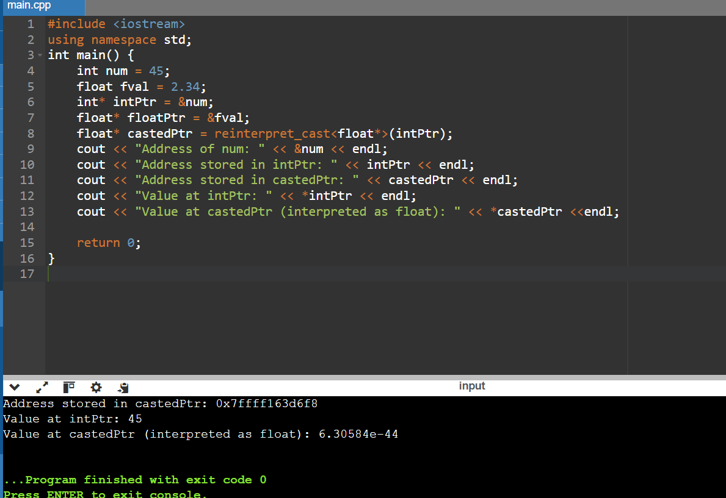

Can you safely cast intPtr to floatPt - Casting an int* to a float* is not safe because of the different internal representations and potential for undefined behavior. The correct approach is to use pointers of the appropriate type for the data they point to, ensuring type safety and avoiding unpredictable behavior. If you need to store both integers and floats, consider using a union or a structure with explicit fields for each type. This ensures that you can safely access and manipulate the data without resorting to unsafe pointer casts.

Q 6 . Casting References - Same Type: Declare an int variable x and an int reference refX assigned to x. Cast refX to a float reference refF. What happens in this case?

#include <iostream>

int main() {

int x = 10;

int &refX = x;

float &refF = reinterpret_cast<float&>(refX);

std::cout << "Value of x: " << x << std::endl;

std::cout << "Value of refF (interpreted from refX): " << refF << std::endl;

return 0;

}

Output:

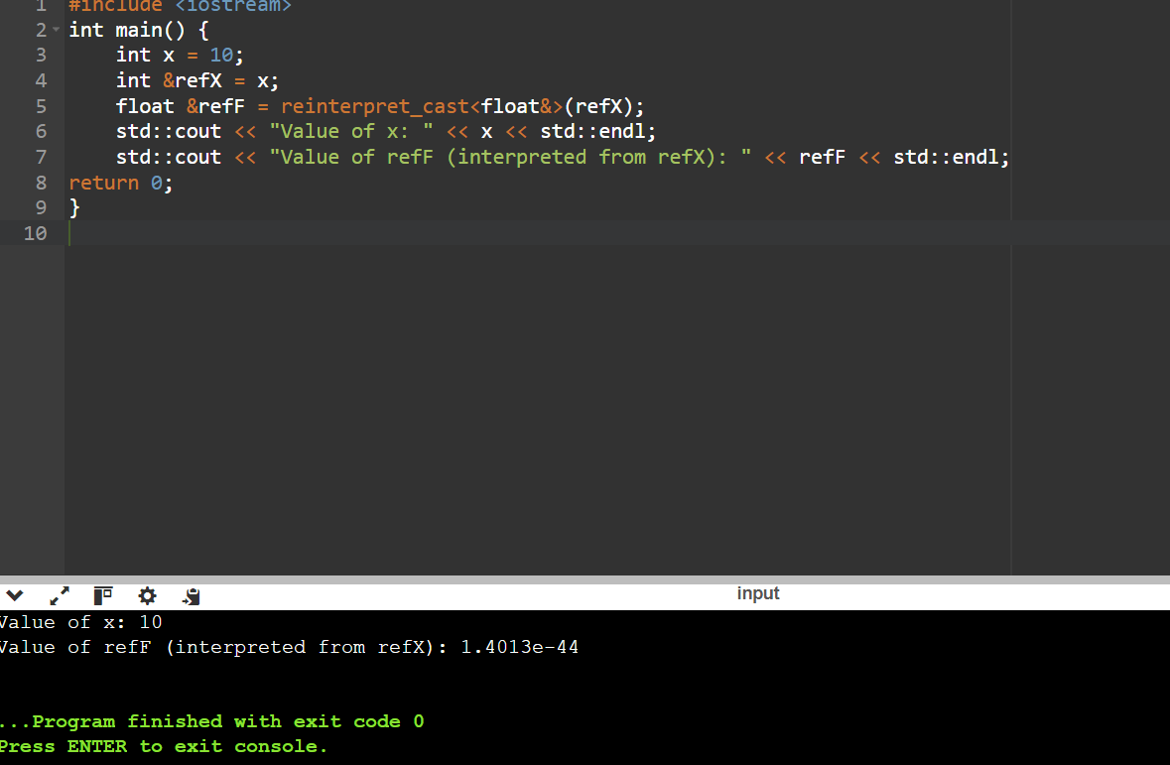

Q 7.

Casting References - Different Types: Declare an int variable x and a float variable f. Initialize an int reference refX with x. Can you cast refX to refer to f? Why or why not?

#include <iostream>

int main() {

int x = 10;

float f = 3.14f;

int &refX = x;

std::cout << "x: " << x << std::endl;

std::cout << "f: " << f << std::endl;

return 0;

}

Output:

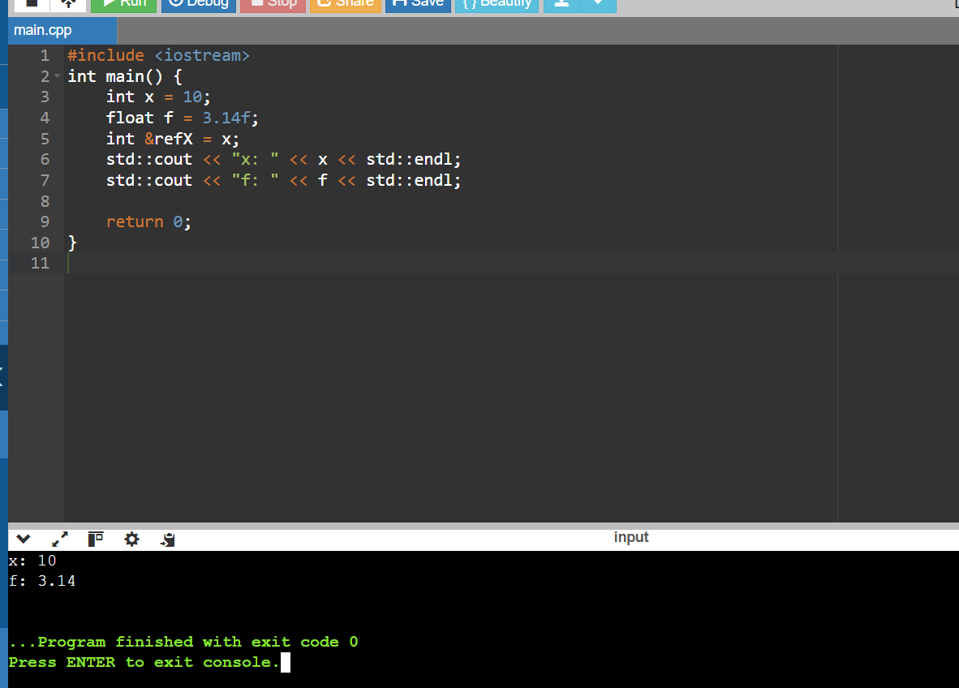

Q 8. Challenge: Area Calculation (Implicit vs. Explicit): Write two functions to calculate the area of a rectangle. One function should take two int arguments for width and height and return an int area. The other function should take two double arguments and return a double area. Discuss the implications of using implicit and explicit casting in these functions.

#include <iostream>

int calculateArea(int width, int height) {

return width * height; }

double calculateArea(double width, double height) {

return width * height;

}

int main() {

int width_int = 5;

int height_int = 3;

double width_double = 5.5;

double height_double = 3.5;

int area_int = calculateArea(width_int, height_int);

std::cout << "Area with int arguments: " << area_int << std::endl;

double area_double = calculateArea(width_double, height_double);

std::cout << "Area with double arguments: " << area_double << std::endl;

return 0;

}

Output:

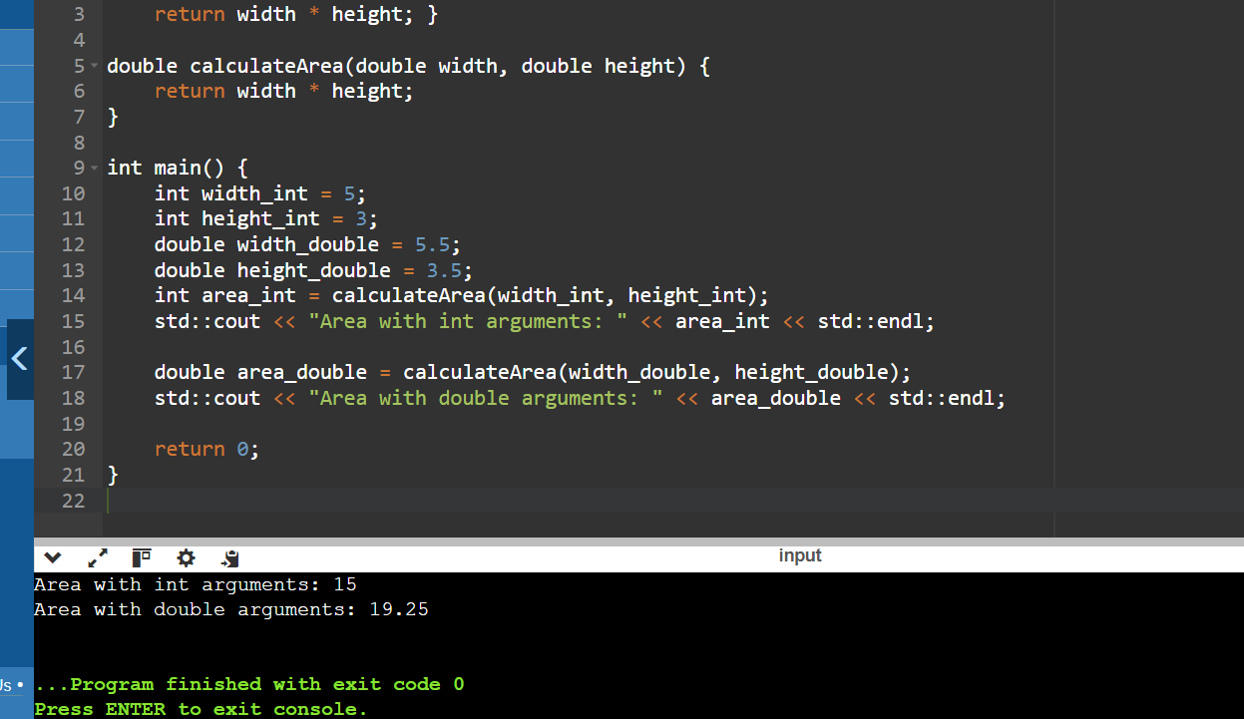

Explanation:

Implicit Casting (int arguments):

Function: int calculateArea(int width, int height)

Implication: The multiplication width * height is performed using int values, and the result is automatically converted to an int before returning. This can truncate decimal places if present in calculations.

Explicit Casting (double arguments):

Function: double calculateArea(double width, double height)

Implication: No casting is needed for the return type (double) because the multiplication width * height is performed using double values. This ensures that the result maintains precision, crucial for calculations involving decimal values.

Main Function: Demonstrates how to call each function with appropriate arguments (int and double) and prints the calculated area.

Choosing the Right Function:

Use the calculateArea(int, int) function when dealing exclusively with integer dimensions to maintain simplicity and avoid unnecessary precision.

Use the calculateArea(double, double) function when dealing with dimensions that may have decimal values to ensure accuracy in calculations.

Q 9. Challenge: Temperature Conversion (Casting and Rounding): Create a program that takes a temperature in Celsius as input from the user. Use explicit casting and appropriate rounding techniques to convert it to Fahrenheit and print the result.

#include <iostream>

#include <cmath>

int main() {

std::cout << "Enter the temperature in Celsius: ";

std::cin >> celsius;

fahrenheit = std::round(fahrenheit * 100) / 100;

std::cout << "Temperature in Fahrenheit: " << fahrenheit << std::endl;

return 0;

}

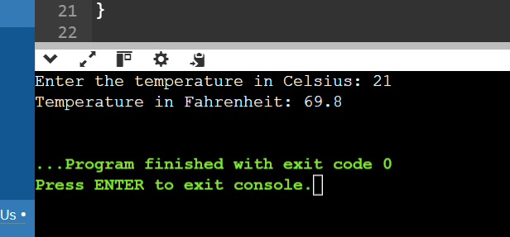

Q 10. Challenge: Pointer Arithmetic with Casting (Safe vs. Unsafe): Demonstrate safe and unsafe pointer arithmetic with casting. Explain the potential consequences of unsafe pointer manipulation. Safe Pointer Arithmetic.

#include <iostream>

#include <cstdint>

int main() {

int arr[] = {10, 20, 30, 40, 50};

int *ptr = arr;

for (int i = 0; i < 5; ++i) {

std::cout << "Element " << i << ": " << *(ptr + i) << std::endl;

} ptr = arr + 2;

for (int i = 0; i < 3; ++i) {

std::cout << "Element " << i << " (after ptr + 2): " << *(ptr + i) << std::endl;

}

return 0;

}

